We will be creating a Web application that takes input parameters and uses them to select an effective study partner or create their own study group. Eg. student location, subject, time, desired cohort, and level of coursework. This information will be stored in a database and when new input is created, relevant students (those with similar needs) will be shown to the user.

We will be using a database of Colleges and universities in the us from <https://ope.ed.gov/dapip/#/download-data-files> to get school data for the forms.

We will be using a made up dataset of students seeking to study with partners or with groups, and forms will be added to the dataset as they are created. The dataset will be stored in a database and coded by assigning random values that will be selectable in the form for each ‘student’, a random city with a population of over 100,000 will be assigned for the location. E.g. student number x’s form will be:

Location: Madison-WI, Studying: Calculus 1, Time: Friday 12-4, phone number: 333-333-3333, Lat-Long: [-45,45], seeking: group study

We will map the approximate locations and display them on a map, which will show the information of the student when the marker is clicked. We will also create a monthly calendar showing the upcoming study sessions taking place in the user’s selected city.

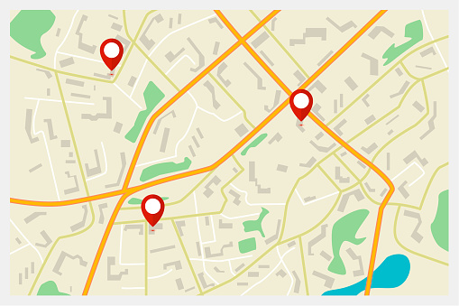

The markers will be present in many us cities and contain information that will be displayed once clicked. There will be filters for which markers are shown. Eg. a user will be able to choose to only display group sessions rather than partner sessions.

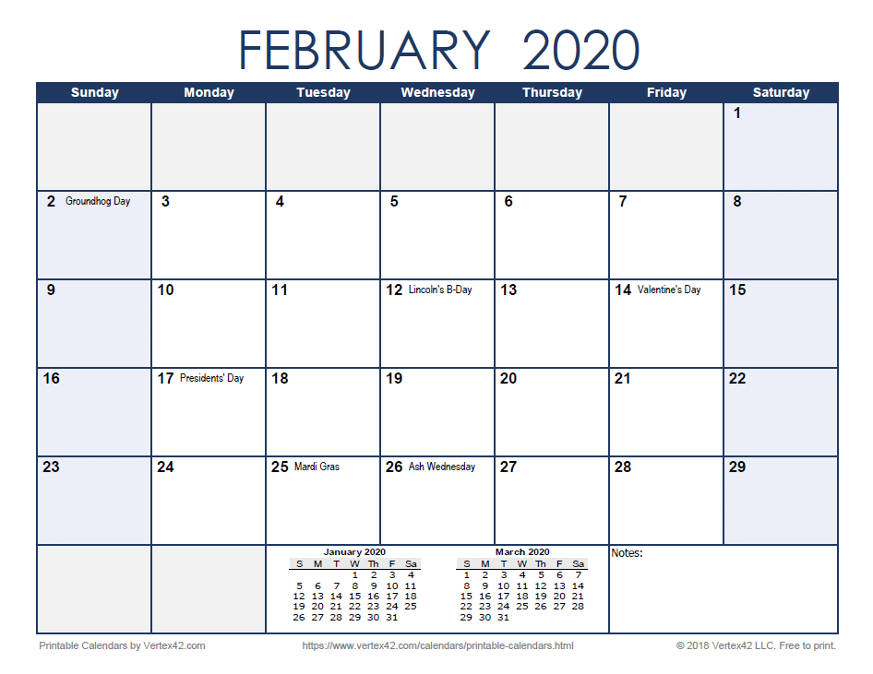

Upcoming events will also be displayed on a calendar, if the user decides. The same parameters will be shown and the user will be able to filter out undesired options. The calendar will only display study groups in the users city by default.